Chapter 11
Fungi as Vectors:
Fungi Can Vector Plant Viruses, Viroids, and Bacteria

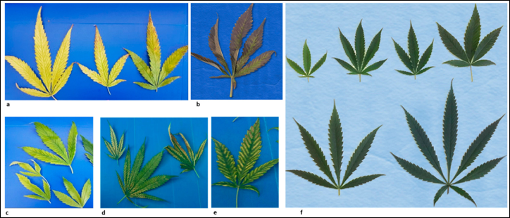
Figure 11.1. Cannabis leaves that have been infected with virus showing various symptoms of viral infection (a-e) compared to healthy Cannabis leaf tissue (f).

Viruses and viroids are an emerging threat among farmers of a variety of crops. Many viruses exist without causing any obvious harm to the host plant or are even beneficial, however effects can range up to devastating host diseases. Viruses are composed simply of DNA or RNA enclosed in a protein coat. Virods on the other hand, are even smaller, containing low-molecular weight RNA without the protein coat. Both Viruses and Viroids rely on the cellular machinery of their host in order to replicate.
Plants naturally acquire viruses and viroids via direct implantation following contact with another living organism (vector) or a nonliving object able to transfer infectious particles (fomite) (Hadidi et al. 2022). Insects, arthropods, nematodes, protozoans, and fungi may vector viruses and viroids. On farms, tools, such as scissors, may be in use frequently enough among different plants to serve as a fomite. This is analogous to the mouthparts of a non-host, insect or arthropod vector transferring viruses. Plants that form root grafts will directly transfer viruses among each other (Root grafts are an important transmission route in other pathogens as well, including fungal pathogens Ophiostoma novo-ulmi (Dutch Elm Disease) and Heterobasidion rot). Pollen can also transfer some viruses and viroids. Seed borne transmission of viruses and viroids is dependent on virus/viroid:host interactions, though generally maternal transmission through the ovule is more common than pollen transmission (Hull, 2014).

Table 10.5.XXX. Known viral, viroid, and phytoplasma diseases putatively affecting hemp. Phytoplasma diseases are obligate bacterial parasites of plants vectored by insects or arthropods.

Viruses | Viroid | Phytoplasma
- Beet curly top virus (BCTV)  - Alfalfa mosaic virus (AMV)  - Arabis mosaic virus (ArMV)  - Cucumber mosaic virus (CMV)  - Tobacco ringspot virus (TRSV)  - Tomato ringspot virus (ToRSV)  - Tobacco streak virus (TSV)  - Tomato mosaic virus (ToMV) | - Hop Latent Viroid (HLVd) | - Candidatus phytoplasma trifolii

Fungi naturally acquire viruses and viroids similarly as plants. Many plant and fungal viruses do not persist outside of their hosts for long, even with protective capsids. Unencapsulated RNA and DNA are usually quickly compromised or destroyed in the raw environment. However, viroids particularly have been shown to be surprisingly persistent without a protective protein capsule; surviving days on surfaces, weeks in water, years in dried plant material, and decades within seed (Singh et al 1977, Singh et al. 1991; Mackie et al 2015). The tertiary structure formed by viroid RNA looping back upon itself is likely responsible for its surprising resilience to degradation and plays a role in its interactions with host proteins (Hull, 2014)
Even if infectious viroids and viruses are present in the environment, plant bodies have protective structures which exclude them. In order to gain entry to an uninjured plant, viruses and viroids may first infect an organism like a fungus which is then able to vector the agent to the plant. Fungi eat by engulfing a solution material through endocytosis (Barata-Antunes et al, 2021). Engulfed material may include infectious agents which then evade digestion.
Fungi were first confirmed to become infected with plant viroids, including active viroid replication, when advocado sun blotch viroid was shown to infect and replicate in bakers yeast, Sacharomyces cerivisea (Delan-Forino et al, 2011). Recently, it has been demonstrated that a variety of plant-interacting fungi are able to host plant viroids (Friday et al 2017, Wei et al 2019).
Andika et al experimentally confirmed the capability of a fungus to vector a plant pathogenic virus into previously uninfected plants (Andika et al 2017, ). The tripartite interaction of cucumber mosaic virus (CMV), Rhizoctonia solani, and Solanum lycopersicum (tomatoes) . This is a particularly interesting model system to demonstrate this phenomenon, given that CMV and R. solani are plant pathogens with very broad host ranges (Cannabis included on both counts), and are therefore relevant to most any farmer or gardener. Rhizoctonia solani is a notorious causal agent of damping off and root rots.
There is no reason to believe that only pathogenic fungi may transmit viruses in this way. The first discovery of a fungus capable of becoming infected with plant viroids was bakers yeast, Saccharomyces cerevisiae (Delan-Forino et al 2011, Friday et al 2017). Though these documented cases were all experimentally infected fungi, and natural viroid infections of fungi have not been identified, it is increasingly accepted that such infections likely occur (Sun and Hadidi, 2022). The ability and likelihood of a particular virus or viroid being vectored into a plant by a fungus is dependent on, not just the host-viroid/virud interaction, but the microbiome and environmental context with which an interaction occurs. Bain et al showed that Cryphonectia hypovirus 1 (CHV1) was able to infect a plant leaf, but could not move systemically through the plant unless the host was co-infected with tobacco mosaic virus (TMV); the viroid relied on TMV movement proteins to be able to move from cell to cell. Interestingly, the this same group also showed that the plant-pathogenic fungi Fusarium graminearum, was more susceptible to TMV infection when it was co-infected with CHV1 (due to CHV1s disruption of the fungal hosts RNA-silencing based immune responses)
Plant mutualistic fungi are likely capable of hosting and transmitting harmful plant viruses in the same manner as pathogenic fungi. It may also be found that bacteria and archaea internalize and transfer plant and fungal viruses/viroids within the environment to new hosts; bacteria and archaea have cellular machinery that serves to internalize exogenous DNA from the environment which then serves as important source of genetic novelty if incorporated into their genome (Wagner et al. 2017).

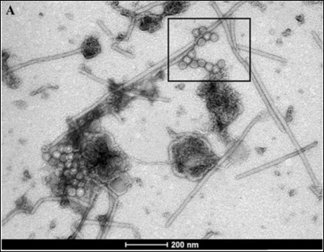
Fig. 11.2. Electron micrograph of virions extracted from cannabis tissue (taken from Ziegler et al 2011)

On farms, mechanical implantation with dirty tools is common. Fungi pass viruses among each other following anastomosis (hyphal fusion) of compatible fungi. Fused hyphae are able to transfer cytoplasm and much of its contents among each other; in the case of ascomycetes, even nuclei flow freely. When fungi anastomize, they also usually transfer any viruses that their cytoplasm contains into the newly fused fungal (formerly) individual. Sometimes, non-compatible fungi will form transient bridges that are a viral transfer risk, even if anastomosis is not stable.
Fungi represent potential reservoirs of plant viruses. It is likely that both mutualistic and pathogenic fungi have complex relationships with viruses, from harmful to helpful, which may infect plants. The 'harmful or helpful' clause here may apply differentially to the same virus infecting a fungus or the plant, as well as under varying conditions.
As a cultivator concerned with viruses, one can limit introductions in advanced markets by selecting germplasm screened for viruses, known to be tolerant of infection, or both. Tools, especially blades, should be sterilized between plants to limit viral movement to limit spread when they do make it onto a farm. Removing the threat of insect pests indoors and creating a competitive environment that limits their impact and population outdoors is an important part of controlling disease transmission. This strategy should be extended to recognize that viruses, viroids, and even bacteria can maintain themselves within a range of alternate host organisms (including fungi) -even in otherwise unfavorable environments. Beyond strong preventative hygiene where appropriate, growers need not be overly concerned with the issue of viruses and viroids unless they are experiencing a problem.

Table 1. Tool sterilization solutions effective at eliminating most plant viroids. Concentration of sterilizing agent and contact time both affect sterilization efficacy (Kai-Shu Ling, 2017).
 | Time |  | Efficacy
10-20% household bleach
2% Virkon
20% Dry Skim Milk

When experiencing a viral problem, the soil or media may be pasteurized or sterilized as part of a 'farm reset' in order to remove much of the living fungi able to host plant viruses. Amending this soil with known disease-free, living- soil or compost will inoculate it with pathogen-free soil microbes. A diverse microbe population in soil will limit the spread of viruses by spatially separating the range of potential host organisms which may interact in a physiological manner capable of resulting pathogen transfer (such as anastomosis of compatible vegetative fungal individuals).
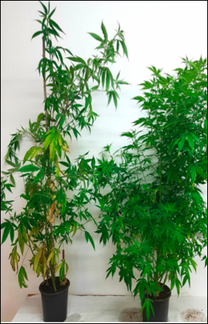
Figure 11.3. Cannabis plant infected with virus (left) vs healthy Cannabis plant (right). (Hadad et al. 2019).

Plant symptoms can range from significant to asymptomatic, therefore sophisticated identification tools are needed. Identifying plants infected with viruses and/or viroids typically relies on laboratory techniques, including ELISA assays, DNA/RNA hybridization or PCR and gel electrophoresis.

